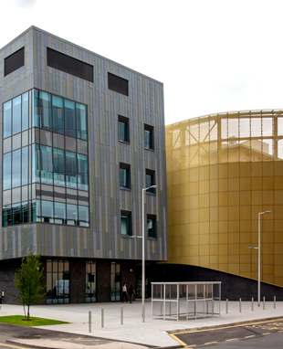

NHSGGC MR PHYSICS MRRP TRAINING EVENT
Venue: Teaching and Learning Centre, Room: L2-011
QEUH campus, Glasgow

1330 Welcome JF, ALL

Keeping Staff Safe / Keeping staff trained

1335 Staff roles: The MRRP, MRSE, MSA & Staff Categories SAS
1350 Authorisation and Entitlement in MRI JF
The EU directive and derogation for MRI

Keeping Patients Safe

1405 Implant policies and where to find them JMCL
1420 Risk assessments DB

1435 Informal break until 1500

Safe use of Equipment at site
1500 Equipment checks (inc quench pipes) JF/MB
Environmental monitoring

1515 Mini group
(follow-up on small group discussion, analysis) PHB,
SAS
CM

Hot Topics
1545 Scanning MR conditional pacemakers RL
1600 The Gd, the bad and the ugly DB

1615 Wrap-up: Questions and Answers JF, JMCL

