Document Details
Author | Jonathan Ashmore
MRSE | Gillian McNaught
Radiographer | Heather Boylan
Other (add rows as required)
Authorisation date (MR safety committee / other committee sign off date) | 11/3/25 (NHS Scotland MR Physics group)
Review Date | 11/3/28
Title: Fixed internal orthopaedic implants

Version History
Version | Date | Description
1.0 | Oct 24 | Original version
1.1 | Feb 25 | Inclusion of Blair Johnston’s Sternal wire GISP into this one
About this document

This template follows the guidance document “A framework for developing Generic Implant Safety Procedures (GISPs) for scanning medical implants and devices in MRI”. Further details on developing a GISP can be found here.
- The procedure statement provides a simple overview of the practical implementation of the GISP (typically completed last).
- The Evidence review contains all the evidence which backs up the risk assessment and procedure statement (typically completed first).
- The risk assessment provides an overview of the risk associated with the GISP
- Roll over each section title for information on how to complete the section
- Each section title links through to relevant online material – mostly this is the joint society published guidance for developing GISPS (still to be published – so currently the links send you nowhere).

Table of Contents
1 Procedure Statement 3
2 Evidence Review 5
2.1 Introduction 5
2.2 Clinical context 5
2.3 Results 6
2.3.1 Online MRI implant safety databases (Date queried: 13/6/23) 6
2.3.2 Locally implanting Teams (Date queried: 07/07/23) 6
2.3.3 Implant Manufacturers (Date queried: 12/6/23) 8
2.3.4 Review of the peer reviewed literature (Date queried: 14/6/23) 13
2.3.5 Internet search (non peer reviewed literature) (Date queried: 13/6/23) 31
2.3.6 Regulatory Medical Device Databases (Date queried: 13/6/23) 33
2.3.7 Regulatory Professional and Standards bodies (Date queried: 13/6/23) 33
2.3.8 Anecdotal evidence (Date queried: 13/6/23) 37
2.3.9 Local MR safety databases and empirical evidence (Date queried: 11/07/23) 42
2.4 Discussion (optional) 43
2.5 References 43
3 Risk Assessment 44
3.1 Hazards 44
3.2 Description of Risk 44
3.3 Existing precautions 46
3.4 Level of Risk 46

Procedure Statement

Disclaimer
Compiled here are Generic Implant Safety Policies (GISP’s) for MRI. While steps have been taken to minimise the risk of adoption of these policies, it should be noted that these are not completely without risk. Health boards, integrated care systems, trusts or private medical organisations should consider carefully whether they wish to adopt these procedures. They should do so via their own governance process and the procedures should be reviewed prior to use. Any institutions use of this policy shall be done so at their own risk. If you are a patient reading this, then we strongly advise you to contact your healthcare provider directly with any concerns prior to attending for your scan, as approaches may vary. It remains the responsibility of the individual registered radiographer to apply their MRI knowledge and professional judgment to the situation under consideration. If there is any doubt regarding the safety of the patient, then additional advice should be sought from e.g. the MR Responsible person MRSE and MR Clinician
Brief description:
Orthopaedic implants help treat and support damaged bones and other orthopaedic structures. These implants can be solely internal or have both internal and external elements (although those with external elements typically are only for temporary use). They vary vastly in size and shape and include pins plates, joint replacements, sternal closure devices, spine correction devices (e.g Harrington rods scoliosis), rib correction devices (e.g Nuss bar for pectus excavatum) to name a few.
Due to the highly variable shape and size of bone structures in the human body, these implants are manufactured in a wide variety of configurations. Many implants are provided as variable modular components that can be constructed to satisfy the requirements of individual patients. As such MR labelling is often not provided for many orthopaedic devices.
Modern metallic versions of orthopaedic implants are typically made from Titanium, Cobalt Chromium or austenitic stainless steel.
What the procedure covers:
All internal orthopaedic implants which are fixed or constrained into/onto bone. This includes (but not limited to):
- Pins, Screws, Plates (including craniotomy)
- Nails and Rods (including Harrington)
- Wires (including sternal)
- Sternal fixation devices
- Joint replacements
- Nuss bars
- Spinal disk replacement and interspinous spacers
What the procedure does not cover, including notable exceptions:
- Active devices such as magnetically activated implants (e.g MAGEC device)
- Any orthopaedic implant with external components (e.g external fixation device)
- Implants which are not well secured into bone.
- Implants that are extremely and abnormally large or have particularly complex configuration (deciding on this is as per radiographers professional discretion).
Advice summary:
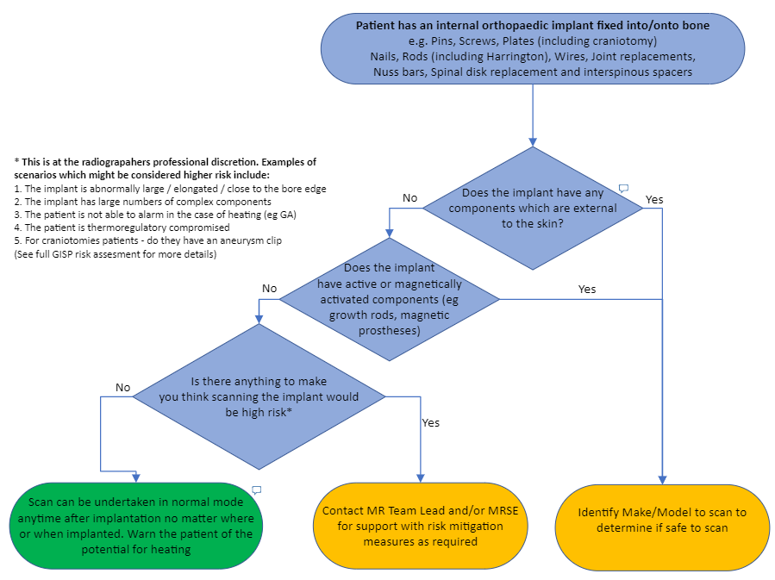

Evidence Review

Introduction

Implementing a GISP within an MRI department has a number of advantages for the department and the patient. These are outlined below:
- Facilitates scanning when implant information is not available and avoids the need for multidisciplinary team review of the specific patient case
- Facilitates immediate scanning when implant information takes some time to obtain, removing delays to patient care.
- Immediate scanning avoids wasted scan slots leading to an improved and more cost-effective MR utilization.
- Reduces the need for staff resources to obtain and evaluate specific implant information.
- Provides an evidence-based methodology for managing patients with implants where there appears to be overly conservative MR conditions.
- Allows greater emphasis to consider implants not covered by the GISP and ensures the safety focus is on these implants which are typically higher risk.
- Evidence based and therefore a more proportionate attitude towards risk

There are also a number of risks of implementing GISPS as outlined below:
- Newly developed or previously unrecognized unsafe implant (or MR Conditional where the GISP does not follow the conditions)
- Updated MR safety information that changes the safety status of an implant such that it is no longer safely scanned under a GISP
- When following a GISP, implants not disclosed by the patient at screening might not be discovered, whereas identifying implant specifics in patient notes can highlight inaccuracies in the patients account of their own medical history.
- Confusion regarding exactly what implants or patient groups a GISP covers. When make and model are identified this ambiguity is removed (e.g. an active orthopaedic implant mistakenly categorised as a passive orthopaedic implant).

Clinical context
Orthopaedic implants help treat and support damaged bones and other orthopaedic structures. These implants can be solely internal or have both internal and external elements. Although those with external elements typically are only have temporary use. They vary vastly in size and shape and include pins plates, joint replacements, sternal closure devices, spine correction devices (e.g Harrington rods scoliosis), rib correction devices (e.g Nuss bar for pectus excavatum) to name a few.
Due to the highly variable shape and size of bone structures in the human body, these implants are manufactured in a wide variety of configurations. Many implants are provided as variable modular components that can be constructed to satisfy the requirements of an individual patients. Given this it can be extremely difficult for manufacturers to undertake accurate testing of orthopaedic implants with numerous potential variations of combination applied to the patient. As such MR labelling is often not provided for many orthopaedic devices.
Modern metallic version of orthopaedic implants are typically made from Titanium, Cobalt Chromium or austenitic stainless steel. There are however historically some examples of ferromagnetic implants. For these it is expected that the strong retentive force provided by the embedding of the implant in bone prevents movement or dislodgement of the implant and there are numerous examples of patients with ferromagnetic implants successfully having undergone MRI exams at 1.5T.
Sternal (sternum) wires are used to close the breastbone after open heart or thoracic surgery. They are typically multiple wires made from stainless steel or titanium but some newer devices include clamps or talons.

Results

Online MRI implant safety databases (Date queried: 13/6/23)
Source | Mrisafety.com
Search terms | Orthopedic, screw, plate, hip, knee,
Status | Number
MR safe | 72
MR Conditional | 78
MR Unsafe | 1
TOTAL | 151

The 1 MR Unsafe device which was identified was the Helix3D device which is a prosthetic joint used in amputees. Hence is not an internal orthopaedic implant. Of the MR Conditional items the most restrictive conditions provide on mrisafety.com were field strength: 1.5T and 3T only, spatial gradient: 720G/cm, SAR: 2W/kg. However, 23 of the implants were labelled as Conditional 5 indicating that the full MR safety conditions should be identified from the manufacturer's website.

Locally implanting Teams (Date queried: 07/07/23)
The NHS Highland nurse in charge of stores and also the Procurement team were contacted to identify a list of orthopaedic implants and devices implanted locally.

Manufacturer | Models/Type | Response | Conditions
Smith and Nephew |  | “Endo’s metal implants are Titanium and MRI compatible. We do not have Ortho’s info in terms of implants which are both Titanium and Stainless Steel” | None provided
Medartis | Implants and instruments for the following APTUS systems are covered by these instructions for use:  - APTUS Hand  - APTUS Wrist  - APTUS Forearm  - APTUS Elbow  - APTUS Shoulder  - APTUS Foot  - APTUS Ankle  - APTUS CCS | “Our implants are made of titanium and therefore safe for use in MRI.” | See here:  Field strength: 3T  Spatial gradient: 19.5T/m.  WB SAR: 2.0W/kg  Scan for 30min. Wait for 30mins for next scan session.  During non-clinical testing, the Medartis implants produced a maximal temperature rise of 26.5 ± 1.8°F (14.7 ± 1.0°C) at 1.5T for a measured wbSAR of 2.12 ± 0.81 W/kg and a maximal temperature rise of 9.9 ± 1.8°F (5.5 ± 1.0°C) at 3T for a measured wbSAR of 2.05 ± 0.88 W/kg both after 15 minutes of continuous scanning.
Arthrex | Question was posed for all models/Types in the suite | Normally when this question comes up we provide the material specification for the product to the clinician or radiologist. Ultimately it is their decision based on their knowledge of that patients condition and the scanner to decide whether that material is ok. As Ross states its not an issue for the PEEK/Polymer based products and normally we just provide the metal specification for plates and screws to enable an informed decision.  Arthroplasty devices maybe an exception to this, I’ve copied in Alex Wilson (Arthroplasty PM) in case he has anything further to add | Conditions for Arthrax Univers Revers Shoulder System found here:  Field Strength 1.5T or 3T  Spatial gradient: 30T/m  WB SAR: 2W/kg (15mins of scanning)  (Under the scan conditions defined, the Arthrex Univers Revers Shoulder System is expected to produce a maximum temperature rise of 3º C after 15 minutes of continuous scanning.)

Manufacturer | Model(s) | Type | Source | Date | Conditions
 |  |  |  |  | Static field | Max  Spatial grad | Max SAR | Other
Johnson & Johnson | 5.5 EXP VERSE UNITIZED SET SCR  (199721001S) | Spinal system: screw | DePuy Synths - Magnetic Resonance (MR) Compatibility (0902-90-158 Rev. B) | 230420 | 1.5T or 3.0T | 19.0T/m | 2 W/kg
Johnson & Johnson | EXP Viper2 lordotischer Stab 45mm, | Spinal system: rod |  | 230420 | 1.5T or 3.0T | 19.0 T/m | 2 W/kg

Implant Manufacturers (Date queried: 12/6/23)

The entries below was obtained from the group at Guy’s and St Thomas NHS Foundation trust on 12/6/23
Manufacturer | Model(s) | Type | Source | Date | Conditions
 |  |  |  |  | Static field | Max  Spatial grad | Max SAR | Other
Johnson & Johnson | 5.5 EXP VERSE UNITIZED SET SCR  (199721001S) | Spinal system: screw | DePuy Synths - Magnetic Resonance (MR) Compatibility (0902-90-158 Rev. B) | 230420 | 1.5T or 3.0T | 19.0T/m | 2 W/kg
Johnson & Johnson | EXP Viper2 lordotischer Stab 45mm, | Spinal system: rod |  | 230420 | 1.5T or 3.0T | 19.0 T/m | 2 W/kg
Johnson & Johnson | ARTIC DELTA CERAMIC 32MM +5  (136532320) | Hip cup | DePuy Synths -  Risks associated with Magnetic Resonance Imaging (MRI) of patients with hip and knee implants | 0520 | 1.5T or 3.0T | 64T/m | 2 W/kg
Johnson & Johnson | APEX HOLE ELIMINATOR POSITIVE STOP  (124603000) | Modular hip replacement |  | 0520 | 1.5T or 3.0T | 64T/m | 2 W/kg
Johnson & Johnson | SUMMIT FEMORAL STEM W/DUOFIX HA 12/14 TAPER SZ4 STD 140MM  (157002100) | Femoral stem |  | 0520 | 1.5T or 3.0T | 64T/m | 2 W/kg
Johnson & Johnson | C-STEM VOID CENTRALISER SZ10  (961210500) | Femoral Stem |  | 0520 | 1.5T or 3.0T | 64T/m | 2 W/kg
Johnson & Johnson | PFC*SIGMA/OV/DOME PAT 3PEG,35  (960101) | total knee replacement |  | 0520 | 1.5T or 3.0T | 32 T/m | 2 W/kg
Stryker | Trident II Tritanium Solidback Acetabular Shell | Hip cup | https://www.stryker.com/us/en/joint-replacement/MRI.html | 010620 | 1.5T or 3.0T | 23 T/m | 2 W/kg | Evaluation was performed using a quadrature body coil only.
 | Trident II Tritanium Clusterhole Acetabular Shell | Hip cup
 | Trident II Tritanium Multihole Acetabular Shell | Hip cup
 | Trident II PSL Clusterhole HA Acetabular Shell | Hip cup
 | Trident II Clusterhole HA Acetabular Shell | Hip cup
 | 6.5mm Low Profile Hex Screw | Screw
 | Hex Dome Hole Plug | Plug
Smith & Nephew Orthopaedics AG | All hip implants. Including sub-components (stem, ball head, cup, insert) | Hip system | https://www.smith-nephew.com/global/assets/pdf/products/mri%20safety%20documents/08559_en_v1_mri_safety_information_hip_0917.pdf | 080620 | 1.5T or 3.0T | 9.3 T/m | < 0.3 W/kg at 1.5 T (local SAR < 0.9 W/kg)  < 0.2 W/kg at 3 T (local SAR < 1.3 W/kg)  Contacted manufacturer for reasons for restrictive conditions 14.07.20 | The defined worst-case combinations were non-clinically tested for radio frequency heating (RF heating) in a MR environment according to ASTM F2182. Before testing mechanically, a computer simulation defined the worst-case systems for RF heating. The implants were non clinically tested for magnetically induced displacement force (ASTM F2052) and torque (ASTM F2213) and image artefacts (ASTM F2119).
Medtronic | SOVEREIGN™ Spinal System | Spinal implant | https://www.medtronic.com/us-en/healthcare-professionals/therapies-procedures/spinal-orthopaedic/olif/indications-safety-warnings/sovereign-spinal-system.html | 080620 | 1.5T or 3.0T | 30 T/m | 2 W/kg
Mathys Medical | Mathys Hip Implants | Hip implant | https://www.mathysmedical.com/Storages/User/Dokumente/Richtlinie-Leitfaden/Leitfaden_MR_E_V02.pdf | 100620 | 1.5T or 3.0T | 30 T/m | a) Devices built in combination without ceramic: SAR ≤ 2W/kg  b) Devices built in combination with ceramic: SAR ≤1W/kg. | Ceramic may cause higher RF-induced heating of tissue around the devices due to interaction effects.  The defined SAR is mandatory if the nearest part of the implant is closer than 30cm from the iso- centre of the scanner.  The effects of local RF transmit coils have not been tested and are not recommended in the area of the implant.  If cerclages are used, the devices have to be at a distance of more than 30 cm from the isocentre of the MRI device.  Combination with other devices has not been evaluated for safety and compatibility in the MR environment. It has not been tested for RF heating in the MR environment. The safety of combination with other devices in the MR environment is unknown. Scanning of a patient with such a device combination may result in patient injury. Therefore, a combination of devices has to be declared as MR unsafe.
 | Mathys balanSys REV Implants | Knee implant |  |  | 1.5T or 3.0T | 30 T/m | 1 W/kg
 | Mathys balanSys Bi/UNI Implants | Knee implant |  |  | 1.5T or 3.0T | 30 T/m | 2 W/kg.
 | Mathys Shoulder Implants | Shoulder implant |  |  | 1.5T or 3.0T | 30 T/m | 2 W/kg.
Biomet Inc. | 3 Variable Angle Compression Hip Screw | Hip screw | http://www.mrisafety.com/TMDL_list.php?goto=30 | 080322 | Up to 3T | 7.2 T/m | 2 W/kg | All these implants are listed on MRSafety.com as MR conditional 6 and are safe to scan up to 3 T.  Note all these implants are relatively small in size.
The entries below were investigated by Jonathan Ashmore NHSH
Nuvasive | Reline System | Screws, hooks, rods, lock screws, transverse connectors, rod-to-rod connectors and iliac connectors manufactured from Titanium and Cobal Chromium – used in the spine | MRI safety jiscmail via Lara Worthington | 250523 | 1.5T and 3T | 44T/m | 2 W/kg | 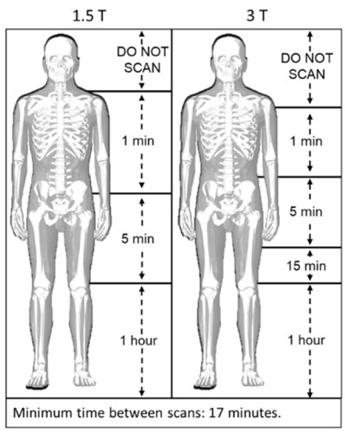  Scan duration as detailed in the MRI Restricted Zone Summary with a cooling period of 17 minutes between scans.  Landmark restrictions as detailed in the MRI Restricted Zone Summary (image above)*
Smith and Nephew | Shoulder Implants |  | https://smith-nephew.stylelabs.cloud/api/public/content/7d61af46f22b44efa51a7239c258ba6c?v=f32b2025 | 271223 | 1.5T or 3T | 41T/m | 0.2W/kg | A temperature increase limit of 2°C was used for extrapolation of “estimated WBA SAR” and “recommended local SAR” based on in vitro test results.
Smith and Nephew | Knee Implants |  | https://smith-nephew.stylelabs.cloud/api/public/content/e80a8e1767d346ff891ad4b59c8f3369?v=f120f55b | 271223 | 1.5T or 3T | 41T/m | 0.2W/kg | Under the scan conditions defined above the Smith & Nephew knee systems are expected to produce a temperature rise of max. 4.0ºC after 15 minutes of continuous scanning

The conditions of the Nuvasive Reline system was discussed in a personal communication with Frank Shellock, Lara Worthington and Nigel Davies. In this conversations it was highlighted that the testing undertaken to define these conditions was flawed and Frank Shellock’s opinion was that treating this implant as per standard imaging (i.e normal mode) was safe.

Additional information regarding sternal wires and fixation devices is below:
Of the 25 sternal wires and fixation devices identified, none were explicitly labelled as MR Unsafe in their IFU. However, two manufacturers, Medicon and Teleflex, have listed their sternal fixation devices as MR Unsafe in the FDA’s Access GUDID database. Medicon did not respond to the request for further information and so all the information that could be found about their sternal fixation devices are that they included titanium sternal locking plates, ladders and screws. The Teleflex locking plate is made from stainless steel but they confirmed in their IFU that it is “non-magnetic”. However, they include the following warning in their sternal locking plate IFU:
“Although sternal locking plates are made from non-magnetic stainless steel, heating and movement may occur under magnetic resonance imaging (MRI) conditions. Therefore, magnetic resonance imaging (MRI) should not be used in combination with implanted sternal locking plates.”
The IFU does not explicitly label it as MR Unsafe but this is perhaps implied. However, the MRI safety statement does not use standard MRI safety terminology and does not present any results from MRI safety testing. If we assume that the manufacturers meant that the stainless steel is non-ferromagnetic rather than non-magnetic, this contradicts the later sentence suggesting there is a risk of movement. Nonetheless, the risk of movement and heating is taken into consideration in this review.
Furthermore, 7 manufacturers stated they had not undergone MR safety testing and 6 provided no MR safety statement. I contacted Zimmer Biomet about their Sternalock device range as the Sternalock 360 is MR Conditional but the Sternalock Blu states it has not been tested and received the following response:
“Our Sternalock product Family has two systems within it, one tested and one waiting on regulatory approval, even though both Sternalock 360 and Sternalock Blu are made of the same material and utilise the same screws we have to test every product brand separately.
Sternalock Blu has been tested but we are waiting on regulatory approval before we can promote it as MRI tested.
Sternalock 360 is a newer to market product as as part of it’s market release and validation it was subjected to MRI testing which why the IFU you sent states some MRI conditions.
Sternalock Blu has been available to the market since 2011 so has a strong history of clinical use and I am unaware of any MRI issues, but until we have regulatory clearance we have to state untested.”
This demonstrates that the manufacturers that have stated devices are untested or those that do not provide an MRI safety statement are not necessarily MR Unsafe.

Review of the peer reviewed literature (Date queried: 14/6/23)
Guo, Ran, Jianfeng Zheng, Yu Wang, Qi Zeng, Qingyan Wang, Rui Yang, Wolfgang Kainz, and Ji Chen. "Computational and experimental investigation of RF‐induced heating for multiple orthopedic implants." Magnetic resonance in medicine 82, no. 5 (2019): 1848-1858.
In this paper numerical and phantom measurement found that the measured temperature rise for multiple devices could be 2.7 times larger than that of a single implant. Conditions which might assure safety for a single implant does not necessarily assure safety when multiple implants are closely spaced. RF heating can be most efficient when long implants are aligned along the axis of the transmit coil.

Liu, Yan, Ji Chen, Frank G. Shellock, and Wolfgang Kainz. "Computational and experimental studies of an orthopedic implant: MRI‐related heating at 1.5‐T/64‐MHz and 3‐T/128‐MHz." Journal of Magnetic Resonance Imaging 37, no. 2 (2013): 491-497.
In this paper they used numerical simulations of an orthopaedic implant which they validate in vitro. An image showing the implant considered is shown below. The table shows a comparison between measured and simulated temperature rises for the same spinal fusion implant which show good agreement following 15 minutes of RF exposure.

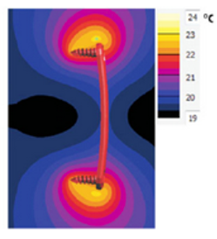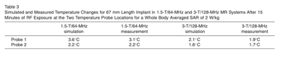

Powell, John, Annie Papadaki, Jeff Hand, Alister Hart, and Donald McRobbie. "Numerical simulation of SAR induced around Co‐Cr‐Mo hip prostheses in situ exposed to RF fields associated with 1.5 and 3 T MRI body coils." Magnetic resonance in medicine 68, no. 3 (2012): 960-968.
In this paper they consider numerical simulation of human models with unilateral and bilateral cobalt chromium molybdenum hip replacements. If the implant is outside of the coil, then it is unlikely to heat up surrounding tissue by any significant amount. If the implant is within the coil volume, then it is possible for local SAR limits to be breached. The presence of multiple well separated implants in this case unilateral/bilateral hip implants, can be considered as non-interacting.

Yamaguchi, Taiki, Yuichiro Abe, Yoshio Ichino, Shigenobu Satoh, Takeshi Masuda, Shoichi Kimura, Manabu Ito, and Toru Yamamoto. "Heating sensation in patients with and without spinal fixation devices during MRI examination at different magnetic field strengths." Journal of Magnetic Resonance Imaging 49, no. 2 (2019): 525-533.
In this paper they report a retrospective study of a previous questionnaire results on heating sensation during MRI of the lumbar spine in patients with and without spinal implants. They surveyed 715 subjects, 101 of which had a spinal implant. There was a significant increase in patients who perceived heating at 3.0T compared to 1.0T (x10). There was no significant difference in perceived heating between patients with or without spinal implants.

McComb, Christie, David Allan, and Barrie Condon. "Evaluation of the translational and rotational forces acting on a highly ferromagnetic orthopedic spinal implant in magnetic resonance imaging." Journal of Magnetic Resonance Imaging: An Official Journal of the International Society for Magnetic Resonance in Medicine 29, no. 2 (2009): 449-453.
In this study they consider the translational and rotational magnetic forces acting on a highly ferromagnetic implant at 1.5T and 3.0T. The implant in question was the Posterior Fixator (Anatomica, Gothenberg, Sweden; previously marketed under the company name Nordopedic). All components of this implant are currently manufactured using AISI 316L stainless steel in accordance with ISO 5832-1 but some components have previously been manufactured with SAF 2507 duplex stainless steel, which has a ferromagnetic component. Although the tested implant exhibits strong ferromagnetism the resulting forces are unlikely to present a significant risk to patient safety for a whole and intact device. However, if the structure of the implant or its anchorage to bone is compromised then forces on individual components could be enough to cause patient harm.

Seo Y, Wang ZJ. Measurement and evaluation of specific absorption rate and temperature elevation caused by an artificial hip joint during MRI scanning. Scientific Reports. 2021 Jan;11(1):1134
In this study they considered temperatures rises in artificial hip joints via numerical modelling and experimental measurement across 5 different MR systems. They found a measured temperature rise of 4.22 °C occurred in the tail region of the hip joint at 1.5 T.
Khodarahmi I, Rajan S, Sterling R, Koch K, Kirsch J, Fritz J. Heating of Hip Arthroplasty Implants During Metal Artifact Reduction MRI at 1.5- and 3.0-T Field Strengths. Invest Radiol. 2021 Apr 1;56(4):232-243
This study measured the temperature rise in hip arthroscopy implants for different metal artefact reduction sequences using in-vitro measurements. It showed a maximum heating of 13.1ºC at 1.5T. The compressed sensing SEMAC sequence produces similar degrees of heating to HBW-TSe sequence.
Heinrich A, Reinhold M, Güttler FV, Matziolis G, Teichgräber UK, Zippelius T, Strube P. MRI following scoliosis surgery? An analysis of implant heating, displacement, torque, and susceptibility artifacts. Eur Radiol. 2021 Jun;31(6):4298-4307.
In the study they considered pedicle-screw-rod implants of length 130-430mm following ASTM standards. Maximum heating was found to be 1.3K. It was found heating increased with the presence of cross-links
J. A. Nyenhuis, Sung-Min Park, R. Kamondetdacha, A. Amjad, F. G. Shellock and A. R. Rezai, "MRI and implanted medical devices: basic interactions with an emphasis on heating," in IEEE Transactions on Device and Materials Reliability, vol. 5, no. 3, pp. 467-480, Sept. 2005
This was a review study of medical device heating undertaken in 2005. The authors summarised that large metallic implants such as artificial joints and cases of IPGs have been demonstrated to experience minimal RF-induced heating because the self-inductance will limit the currents and the smooth edges will limit the concentration of power deposition… the greatest potential for RF heating of implants is for very elongated structures, such as guide wires and leads, and also structures that form a resonance loop.
Wooldridge J, Arduino A, Zilberti L, Zanovello U, Chiampi M, Clementi V, Bottauscio O. Gradient coil and radiofrequency induced heating of orthopaedic implants in MRI: influencing factors. Phys Med Biol. 2021 Dec 23;66(24).
In this study they considered the theoretical half wavelengths that lead to the antenna effect of maximum implant heating. They found the theoretical half wavelength was 41cm in soft tissue and 53cm in bone at 1.5T which matched measured values from previous published studies.

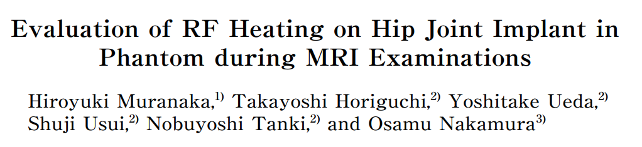
In this study from 2010 they considered phantom studies of cobalt chromium and Titanium hip replacement. The implants were positioned at a 2cm depth and orientated parallel with the static magnetic field. Scans were conducted at 2.5W/kg for 15mins and the maximum temperature rise was 9ºC for Cobalt Chromium and 5.3ºC for Titanium.

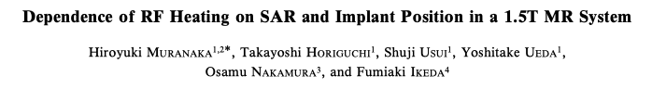
In this study from 2007 they considered heating of a 24cm humerus nail in a phantom. They considered various locations of the implant and found a maximum temperature rise of approx. 6.4ºC at 2W/kg. They noted that heating was increased when the nail was positioned parallel with the axis of the transmit coil and when it was embedded at a shallower depth. They note that actual temperature rises in tissue would likely be smaller due to the cooling effects of perfusion.

Graf, Hansjörg, Ulrike A. Lauer, and Fritz Schick. “Eddy‐current induction in extended metallic parts as a source of considerable torsional moment.” Journal of Magnetic Resonance Imaging: An Official Journal of the International Society for Magnetic Resonance in Medicine 23, no. 4 (2006): 585-590.
In this study they consider eddy current induced torque on orthopaedic implants to identify if gradient fields elicit movement of devices. They found that gradient induced torque can be significant for larger implants in off centre locations. They suggest this effect may explain why patients with extended metal implants sometimes report feeling sensations during MRI.

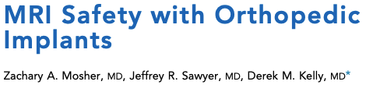
In this study from 2018 they reviewed the current literature on the safety of orthopaedic implants. In their review they provide a summary table of previous implant studies highlighting the maximum deflection angle was found to be 65º for the Anatomica posterior spinal fixator and they highlight that this device had highly ferromagnetic components (note this is the data from the study listed above by McComb et.al 2009). In total 4 implants tested displayed deflection angle greater than 45º. In terms of heating the highlight the maximum heating displayed was 14.7ºC for a humeral nail implant. This data was obtained from the Muranaka et.al. 2007 study above the difference in values listed compared to above is due to Mosher study highlighting the temperature rise for the maximum SAR rather than the SAR set to 2W/kg. In the Mosher study they concluded: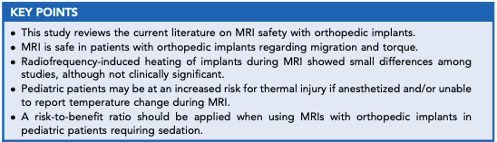

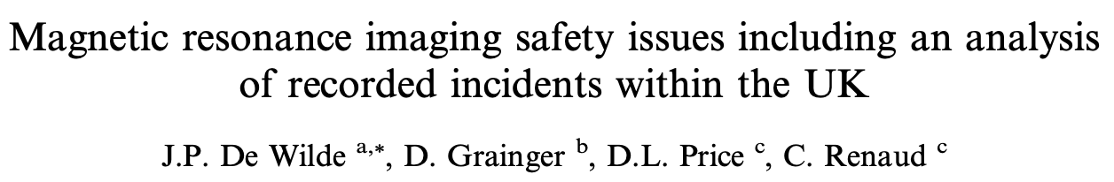
In this article from 2007 they report a case of heating and pain surrounding a bilateral hip replacement. The scanner was imaging with a SAR of 1.5W/kg when the patient experienced the pain. When the patient was bought out of the scanner the pain went away.

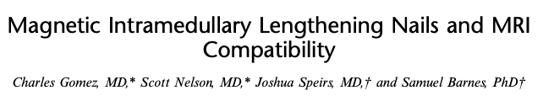
In this article from 2018 they test the PRECICE intramedullary lengthening nail which was placed inside osteotomized tibial and femoral saw bone models. They found the ferromagnetic projectile force was 2lbs at 3T and given how this is fixed into bone they considered this force to not be clinically relevant. They identified temperature increase of 3.6ºC at 3T (0.5ºC at 1.5T) although some uncertainty how accurate their saw bone models are in terms of tissue equivalence for electromagnetic properties. They also tested if the extension of the implants changed due to the MRI exposure which it didn’t. Finally, they tested if the force the implant applied to the saw bone model changed when it was activated before and after MRI. They found the force was significantly less due to exposure to MRI but only at 3T (not 1.5T).

Katsuyuki Iwatsuki,¹ Hidemasa Yoneda,¹ Tetsuro Onishi,¹ Hisao Ishii,¹ Shigeru Kurimoto,¹ Michiro Yamamoto,¹ Masahiro Tatebe,¹ and Hitoshi Hirata¹ Compatibility of magnetic resonance imaging in patients with orthopedic implants: manufacturer questionnaires Nagoya J Med Sci. 2020 Feb; 82(1): 79–84.
In this article the authors sent out a questionnaire to 12 manufacturers of orthopedic implants asking the question: “Is your product compatible with MRI”. All manufacturers replied with the following answer “MRI cannot be performed, or the manufacturer does not approve MRI use (cannot issue a certificate)”. It should be noted though that this was specific to Japan and so responses maybe be different for other territories. In the article a list of implants was given which provided the justification from the manufacturers for not being able to advocate MRI for their suite of implants.
Note from Jonathan Ashmore: I subsequently searched for these implants on the internet and where MR information could be determined the implants were MR Unlabelled and the manufacturer highlighted they were untested and therefore pose an unknown risk in MRI.

Case report: Significant patient burn due to interaction of a complex sternal closure system and MRI McGrath C, McCann AJ, Bartlett A, Grant B, Beattie GW, Donnelly J and Kanal E

This report highlight a burn to a 2 year old child with Robicsek sternal closure system (sternal wires). The patient received a cardiac MRI and the subsequent days after the MRI the patient developed a 3rd degree burn. The location of the burn was directly over the sternal wires and the authors implicate SAR heating from the MRI as the source of the injury.

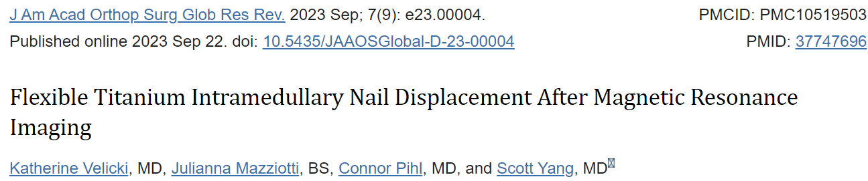
This article highlights a case report of a 7yr old patient with a titanium alloy nail to treat radius and ulna malunion. 4 weeks after surgery they had a sedated brain MRI and woke up from anaesthesia with elbow pain. They subsequently had the cast removed and found the implant had migrated (see images).
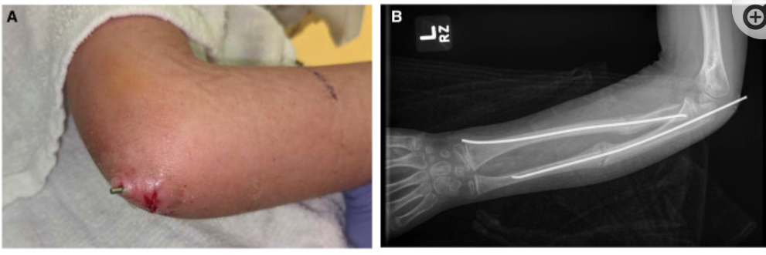
They noted that the implant had been tested at 3T and torque and displacement within ASTM standards. They suggest that the MRI may have caused vibrations of the implant which gradually shifted its position over the course of the MRI. They highlight that special consideration should be given to sedated patients who cannot communicate their symptoms during MRI
Additional References Merged from the Sternal wires GISP (26/7/21).
Search terms used in Google Scholar included: “sternal wires MRI” and “MRI safety sternal wires”. Further papers were identified through the references found during the literature review and internet search. 15 articles were investigated, all of which discussed MRI safety of sternal wires or other sternal fixation devices.
No reports of injuries or safety concerns from sternal wires or other sternal fixation devices in the MR Environment were reported. Symons and colleagues (2019) reported one case of a paediatric patient reporting discomfort during MRI performed 2 days after cardiac surgery. The discomfort stopped following the discontinuation of the MRI examination. Due to the similar symptoms, it is unclear whether the pain was due to the sternal wires or anxiety.
All of the literature found stated that sternal wires/sutures are safe to scan, with most stating up to 3T (Baikoussis et al (2011), Levine et al (2007), Shellock (2002) and Zheng et al (2019)). Baikoussis and colleagues (2011) added that these can be scanned immediately after implantation. Diken and colleagues (2016) also mentioned screws, adjustable clips and nitinol clips used for sternal closure are usually made from titanium and nitinol and therefore do not represent a contraindication to MRI. Levin and colleagues (2010) report that the KLS Martin Sternal Talon (Figure 1) is “magnetic resonance imaging compatible” but provide no MR Conditions. Thermoreactive nitinol clips were also reported to be “compatible” with MRI, suggesting these are MRI Conditional devices (Negri et al, 2002).
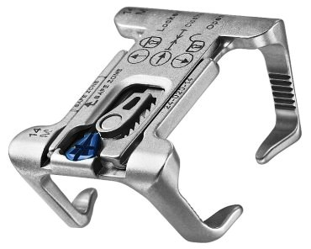
Figure 1: KLS Martin Sternal Talon
One paper by Leitgeb and colleagues (2013) stated that, from a heating perspective, “metallic sutures as used to fix the sternum after thorax surgery are no contraindication for MRI with static magnetic flux densities up to 7T”. Furthermore, a single break in a sternal wire does not increase the risk of heating. However, as Shellock noted on the SMRT mailbase: “the investigators only performed numerical anatomical and thermal modelling in this study and did not include actual temperature measurements to confirm their findings. Regardless, the information is interesting and included work up to and including 7T”.

Additional References provided from the MRSE review – General mechanisms of heating.

Progress in Understanding Radiofrequency Heating and Burn Injuries for Safer MR Imaging. Minghui Tang1 and Toru Yamamoto2* Magn Reson Med Sci 2023; 22; 7–25

A literature review concluding that the evaluation of local SAR is crucial for preventing RF burn injuries. However local SAR cannot be monitored in real time. Instead, we have to rely on simulations of RF heating to predict the local concentration of induced RF eddy current differences that may lead to burn injuries. They highlight studies that found a higher risk of RF burn injuries occurring near the transmit coil, suggesting that patient positioning that avoids a strong electric field in the MRI scanner would reduce the risk of RF burns. Avoidance may be more difficult to achieve in larger/broader patients.
They also advise paying close attention to the antenna effect for large implants.
Conclusions relevant for Orthopaedic GISP:
- They reported that MR safety incident reports from 3 countries (UK, USA, Japan) indicated that “contact” on human body is the key feature of most reported RF burn injuries.
- They conclude that even when MR safety regulations for RF heating are ensured during MRI examinations, RF burn injuries occur and the mechanism of these injuries requires further investigation.

Murbach M, Neufeld E, Capstick M, et al. Thermal tissue damage model analyzed for different whole-body SAR and scan durations for standard MR body coils. Magn Reson Med 2014; 71:421–431.

They highlight that whole body and partial SAR measurements correlate poorly with localised SAR (i.e. SAR averaged over any 10g of temperature) and with local temperature rise.
They list the key parameters that determine local temperature increase as follows:
- The electromagnetic exposure level.
- The spatial distribution of SAR, specific heat capacity, thermal conductivity, metabolic heat generation and transient blood perfusion of the tissue.
- The thermal boundary conditions (convection, sweating etc..).
They highlight local thermoregulation as being particularly important with regards to the occurrence of local hot spots occurring during MRI induced RF heating.
They report that local SAR correlates poorly with temperature increase. Instead, they report that temperature weighted time integrals correlate best with tissue damage, and they advise that safety guidelines should be based on thermal dose models (e.g. CEM43) rather than local or whole body SAR.
In simulations they set tissue-specific CEM43 thresholds as follows:
a. CEM43 = 15 minutes for muscle, fat, skin and bone tissue
b. CEM43 = 2 minutes for all other tissues
The peak temperature in multiple tissue regions were simulated in multiple models (Duke, Ella and Fats) for simulated MR sequences assuming 10 different landmark positions. They showed that the highest temperature resulted when a pelvis landmark position was assumed. As expected, the largest model (named Fats) had the highest peak temperatures, reaching the tissue damage thresholds first for all configurations. In the largest model when imaging at the position of the pelvis, muscle was found to reach the tissue damage threshold first (after 25 minutes of scanning at 4W/Kg).
The importance of thermoregulation in reducing peak temperature is highlighted in the simulation results. They concluded that thermoregulated perfusion is the most influential parameter in reducing local tissue temperature. All other factors (sweating, airflow, room temperature) modify skin temperature but have little influence on local internal peak temperatures.
The study demonstrated that the limit for local tissue temperatures was exceeded in all positions for the Fats and Duke model in the first level operating mode.
Conclusions relevant for Orthopaedic GISP:
Murbach et al hypothesise reasons that explain why in clinical practice there does not appear to be the level of local RF injury in MRI that is predicted by the simulations:
- Most MRI scans are carried out on conscious patients that are able to give immediate feedback on heating, thus preventing injury.
- The manufacturers safety measures likely prevent the maximum allowable SAR in 1st level operating mode (4W/Kg) (i.e. the IEC limits are likely never reached).
- MRI exams generally have time gaps between sequences thus lowering the average SAR. Clinical scans tend to be an average of 30 minutes again limiting SAR.
- They also suggest that some tissues such as muscle may have limited heat sensation.
Murbach et al summarise that the highest risks of RF heating arise from a combination of the following factors:
a. First level operating mode
b. Long scan times
c. Anatomically large and obese patients
d. Patients with disabled or partially dysfunctional perfusion abilities (e.g. elderly, diabetic) or heat sensation (e.g. paraplegic).

Nordbeck P, Fidler F, Weiss I, et al. Spatial distribution of RF-induced E-fields and implant heating in MRI. Magn Reson Med 2008; 60:312–319. (Ref 3)

The aim of this study was to systematically investigate how implant positioning within a volume affects implant heating during MRI. The secondary aim of the study was to assess the correlations between E-fields induced in the human body and implant heating.
They measured the Electric field in different locations of an acrylic glass head/torso phantom in a 1.5T scanner when landmarked to the geometric centre of the phantom torso (registered supine head first and weight of 45kg). They found that the Electric field was highest near the walls (maximum when the sensor was orientated parallel to the long side of the phantom (z-direction)).
They also carried out RF heating measurements of a 200mm straight stainless-steel rod (1.5mm diameter, both ends cut with flat faces) when the rod was positioned at different locations within the phantom. Minimum heating was found in the middle of the torso phantom with the implant orientated to the scanner z-direction. Increased tip heating was reported for off-centre positions, with local variations in heating between the implant tips being demonstrated for differences in the angle of the implant (e.g. where 1 tip is orientated closer to the scanner wall than the other).
They conclude that a specific hazard arises for implant RF heating where an elongated implant is positioned parallel to the distribution of the induced Electric field in the body and in regions of high Electric field. They caution that consideration of local Electric file in addition to local SAR is necessary to predict implant heating. They also note that body tissue distribution can lead to major differences in RF-related Electric field distribution in the human body, making it difficult to absolutely predict implant heating in vivo.
Conclusions relevant for Orthopaedic GISP:
- In the Z-direction the Electric field is highest at the periphery of the torso and in the x-direction the Electric field is maximum across the shoulders and across the pelvis.
- There is minimal heating if the implant is positioned orthogonal to the local Electric field distribution or in regions with overall low Electric field.
- This means that heating would be greatest for an elongated implant in the arm or in the periphery of the thorax and orientated parallel to the scanner z-direction.
- Heating would also be increased for an implant at the level of the shoulders/clavicle or at the level of the pelvis and orientated parallel to the scanner x-direction.
- This means there would be minimal heating for orthopaedic implants in a spine of normal anatomy i.e. the centre of the body. An orthopaedic spinal implant would meet the neck and the pelvis in an orientation orthogonal to the electric field in these regions, and so heating would still be minimised in the spine implant.
- Bar-like implants orientated across the upper thorax (scanner x-direction) could be subject to increased RF heating (e.g. potentially the pectus bar) if the landmark position is for bottom of chest/top of abdomen as was the case for the phantom measurements carried out in this study.

MRI-Related Heating of Implants and Devices: A Review
Lukas Winter et al 2020, J. MAGN. RESON. IMAGING 2021;53:1646–1665

Winter et al provide a useful comparison of RF heating and gradient heating. Whereas the RF field has a higher frequency than gradient switching (~ 10⁸Hz vs < 10⁵ Hz), the RF field has a significantly lower magnitude (~10µT vs ~10mT). Winter et al give an example showing that switched gradients deposit significantly more power compared to RF in a non-magnetic sphere of dimension and conductivity similar to that of femoral head of a CoCrMo alloy. Switched gradients delivers 900mW (BG = 6mT, f=1kHz) compared to 8mW for an RF field of 10µT at 64MHz.
Conclusions relevant for Orthopaedic GISP:
Specifically considering orthopaedic implants, the greatest concerns are as follows:
- RF heating:
Multiple implants with short gaps between them are most critical, especially if these implants are elongated, thin, have pointed ends and are aligned with the background Electric field (i.e parallel to the magnet axis). As orthopaedic implants are often constructed in bespoke configurations depending on specific patient needs, there is opportunity for a series of orthopaedic implants to meet the description of the most critical case for RF heating.
This would not be of considerable concern for orthopaedic implants in the spine. This is because “normal” spine anatomy tends to be positioned centrally within the body which would be the point of lowest Electric Field. Greatest concern would be an elongated implant with pointed ends orientated parallel to the Bz-direction of the scanner and at the periphery of the torso/pelvis or in the arm or leg, particularly in large patient who would be closer to transmit coil. This would include hip implants.
- Gradient heating
Bulky implants with large cross-sections and high electrical conductivity are at greater risk from gradient heating, especially if positioned at the location of maximum gradient amplitude (~30-50cm from isocentre) and orientated perpendicular to the gradient fields. Orthopaedic implants that would fall in the category of bulky/large cross-section are hip implants and potentially also the pectus bar, in particular those made from higher electrical conductivity materials such as Co-Cr-Mo alloy.
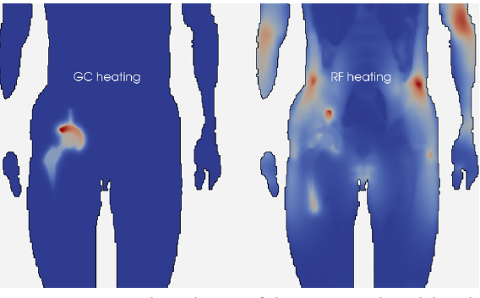
Figure by Winter et al demonstrating heating in a hip implant via imaging gradients (left) and via RF (right).

Additional References provided from the MRSE review – Orthopaedic implants.

Classification Scheme of Heating Risk during MRI Scans on Patients with Orthopaedic Prostheses. Valeria Clementi 1 , Umberto Zanovello 2,* , Alessandro Arduino 2 , Cristina Ancarani 1 , Fabio Baruffaldi 1 ,Barbara Bordini 1 , Mario Chiampi 2, Luca Zilberti 2 and Oriano Bottauscio Diagnostics 2022, 12, 1873.

Clementi et al assessed the heating risk associated with MRI exams on patients with hip, knee or shoulder arthroplasty. They assessed heating in 588 clinical scenarios (196 gradient heating scenarios and 392 RF heating scenarios). They used simulations to assess RF and gradient heating of 4 types of implants (2 hip, 1 knee, 1 shoulder) when considering 7 different scan regions. They simulated whole body and local SAR for 7 different clinical MR sequences (shoulder, thorax, abdomen, pelvis, femur and knee).
They found that 50/588 scenarios required “some caution”, meaning that these scenarios breached pre-defined limits for local heating.
The whole-body SAR limits were never breached, even in cases where local SAR limits were exceeded.
For RF heating scenarios, shoulder implants were subject to highest local heating (3rd tier – defined as breaching a SAR limit). For shoulder implants it is always the local SAR threshold that is breached when imaging over the shoulder or the thorax. Hip implants were subject to increased heating when imaging over abdomen, pelvis or femur.
Gradient heating for hip implants is consistently high for all imaging locations, although only reaching the 2nd tier risk (defined as less than 2 degrees Celsius increase by end of sequence but that this temp threshold was exceeded by the time that steady state was reached – not an entirely clear definition). It says that “as for RF, knee consistently breached tier 3”. Presumably this is when considering gradient heating alone where in this case Tier 3 is defined as breaching the 3 degrees Celsius limit at the end of the sequence.
- Conclusions relevant for Orthopaedic GISP:
This again confirms that orthopaedic implants located at the periphery of the body, for example in the shoulder and hips, are subject to the highest local heating. This is in keeping with such areas being closest to the RF transmitter and being in the highest background Electric field. Gradient heating (local SAR) in a knee implant could be significant.

Heating of hip joint implants in MRI: The combined effect of RF and switched-gradient fields. Alessandro Arduino, Umberto Zanovello, Jeff Hand, Luca Zilbert, Rüdiger Brühl, Mario Chiampi, Oriano Bottauscio. Magn Reson Med. 2021;85:3447–3462

A total of 288 simulations were performed on the “Duke” model (male, height 1.77m, weight 70.3Kg) assuming a unilateral hip implant on the right side. The hip implant was modelled as being made from CoCrMo alloy with length 230mm (from lower tip to top of femoral head).
The simulations were performed for all combinations of four clinical sequences (TSE, EPI, GRE, TrueFISP), 12 body positions, 3 power cases and 2 Larmor frequencies (64 and 123MHz). Simulated temperature increases within the body (at the location of the simulated hip implant), rather than SAR, were used as a safety metric. Temperatures were measured for simulations of each sequence assuming a 5-minute acquisition time. Using the local temperature limit of 39°C for normal operating mode (IEC) and 41°C as being the most stringent limit for potential harm to tissue (ICNIRP), this study employed temperature increase thresholds of 1°C and 3°C to assess simulation results (i.e. this assumes a maximum tissue temperature of 38°C before scanning).
Results are shown across 12 body positions grouped into 4 categories – femur/knee, pelvis, abdomen, thorax. They indicate that “iscoentre” is z=0 (at the junction between abdomen and pelvis) and that the 12 points on the graphs indicate the position of the head of the hip implant relative to isocentre. I don’t think they mean isocentre as per its usual definition (i.e. referring to MRI landmark position), as isocentre would normally be defined as being within the imaging volume.
As expected, RF contributions to heating are generally higher at 3T compared to 1.5T whereas gradient heating was similar for both field strengths. Also as expected, for gradient echo and EPI sequences, gradient heating is higher than the RF heating contribution. The highest gradient heating at the hip implant position is reached with the EPI sequence for femur/knee and thorax imaging positions (2.34 and 2.42°C respectively). Clinically the EPI sequence is not necessarily used at these locations, but the authors say this is representative of all GRE sequences – I disagree with this as gradient heating for standard GRE sequences are minimal at the hip implant position for all imaging locations (max heating at hip implant of 0.058°C when imaging the thorax). The TrueFISP sequence is likely to be used for thorax imaging and these simulations show that this sequence applied to thorax imaging positions results in gradient-relating heating of 1.07°C at the position of the hip implant. The highest RF heating is reached with TSE sequences for pelvis imaging positions (>4°C).
Conclusions relevant for Orthopaedic GISP:
These simulations for a single hip implant show that the contribution from RF heating when imaging over the implant results in significantly higher heating than the worst-case gradient heating scenario. However, this is just a set of simulations for one hip implant with limitations of assumed materials, body habitus and clinical sequences assessed. Gradient heating contributions cannot be ignored and could be significant for bilateral hip implants and other combinations of orthopaedic implants.
This study showed that local temperature limits can be exceeded in a shorter time (5 mins) than that used in ASTM testing (15 minutes). However, in clinical practice with clinically relevant sequences, local temperature rises can be reduced by interleaving high and low-heating sequences, relevant for the known greatest contribution of heating for the patient’s implant type/location.

Radiofrequency induced heating of biodegradable orthopaedic screw implants during magnetic resonance imaging Jonathan Espiritu, Mostafa Berangi b,c,d, Hanna Cwieka, Kamila Iskhakova, Andre Kuehne, D.C. Florian Wieland, Berit Zeller-Plumhoff, Thoralf Niendorf, Regine Willumeit-R¨omer , Jan-Marten Seitz. Bioactive Materials 25 (2023) 86–94
Mg-based orthopaedic implants undergo degradation over time when exposed to bodily fluids. This causes a change in the chemical composition and physical geometry of the implant. This study investigates how the degradation layer formed around the base material of a magnesium based biodegradable screw modifies RF heating during MRI.
When imaging patients with Mg-based orthopaedic implants using MRI, there is lower metallic artefact but potential for increased heating due to increased conductivity.
The material, shape, location, orientation, and degradation state of a conductive implant dictate variations in RF power deposition and heating due to the imaging gradients.
For orthopaedic screws, direct implant heating of such a small mass may be negligible but the secondary (scattered) E-field induced by eddy currents is a major contributor to RF induced heating.
For 1-dimensional geometries, the antenna effect must also be considered but for the 40mm screws assessed in this study, that is not relevant.
There was found to be no significant difference in temperature measurements of an un-degraded Mg-based screw and a standard titanium screw used in fixed orthopaedic implants (both experienced about a 1 °C temperature increase).
This study found that the degradation layer that forms on the outside of the implant is mostly composed of Mg(OH)₂ in both crystalline and amorphous forms. Mg(OH)₂ is a poor conductor and it is concluded that this layer serves to reduce the scattered E field and hence would result in reduced RF heating in biodegraded magnesium based orthopaedic implants.
They propose changes to the ASTM testing standard specific for biodegradable materials and advise that further testing of a range of biodegradable orthopaedic implants are similarly tested.
Conclusions relevant for Orthopaedic GISP:
This is the first study to assess the RF heating profile of magnesium-based biodegradable orthopaedic implants. It seems for this type of material that RF heating will reduce with increasing degradation of the material. This may not be the case for other materials. The MRI Physics community should regularly review literature for RF heating studies of biodegradable orthopaedic implants and update the orthopaedic GISP if required.
Additional References provided from the MRSE review – Gradient heating.

The Underestimated Role of Gradient Coils in MRI Safety Luca Zilberti,1* Alessandro Arduino, Oriano Bottauscio, and Mario Chiampi. Magnetic Resonance in Medicine 77:13–15 (2017)

Zilberti et al highlight the significant heating that can occur in electrically conductive bulky implants positioned at distance from isocentre (i.e. at point of maximum imaging gradient). This results from the direct heating of the implant via induced eddy currents and subsequent thermal conduction leading to heating in adjacent tissues.

Gradient Heating of Bulk Metallic Implants Can Be a Safety Concern in MRI. Rudiger Bruhl, Albrecht Ihlenfeld, and Bernd Ittermann. Magnetic Resonance in Medicine 77:1739–1740 (2017)

Bruhl et al demonstrate substantial gradient heating of a hip implant made from Ti-6Al-4v alloy. Even greater gradient heating occurs in CoCrMo. They used an EPI sequence in this study (gradient strength 20T/m and slew rate of 200T/m/s, frequency of 2kHz). Limiting the scanner output to Normal Operating Mode, they found that an implant embedded in gelatine gel experienced a 3.8°C temperature increase. They do not provide the necessary simulations to translate this implant heating into an estimated temperature increase in surrounding tissue. They also report a temperature increase of 25.8°C when the implant is “insulated” in polystyrene. However, the implant embedded in gelatine seems like the most clinically relevant situation.
They conclude that although gradient heating cannot automatically be assumed to be dangerous, it must not be ignored.
Conclusions relevant for Orthopaedic GISP:
Caution is required when imaging a patient with bulky electrically conductive orthopaedic implants when the implant would experience the highest imaging gradients (e.g. a hip implant could be positioned at the point of highest imaging gradient when scanning thigh or chest/abdomen).
Additional References provided from the MRSE review – Large Incident Reviews.

MRI-related FDA adverse event reports: A 10-yr review Jana G. Delfino, Daniel M. Krainak, and Stephanie A. Flesher Med. Phys. 46 (12), December 2019

Delfino et al provide a very useful breakdown of frequency of incidents reported to the FDA over a 10-year period. Thermal incidents are the most frequent (906 - 59%) by a significant margin to the next most frequently reported category of incidents (mechanical, 170 - 11%). They define a Thermal incident as resulting in skin reddening, blisters, burns, warming, heating sensation, fires and smoke. Projectile incidents were the 3rd most frequently reported (133 - 9%). Interestingly the category labelled as Miscellaneous is the 4th most frequently reported (109 - 7%). Miscellaneous is defined as adverse event reports for which a sufficient narrative was provided to describe the event that have been clearly linked to or caused by the MR system, but the event did not fit into any of the other categories. There were 55 incidents (4%) labelled as ‘Unclear’ as there was insufficient information available to draw any conclusions.

Delfino et al provide further details of incidents in each category. For thermal injuries the majority of incidents in this category (348 - 39%) were labelled as Unclear. The 2nd most frequently reported thermal injury was attributed to contact with an object (257 – 28%), the 3rd to skin-to-skin contact (147-16%), the 4th to bore contact (97 – 10%) and the 5th were defined as ‘not RF-related’ (57 – 6%).
MR coils (138 – 54%) and ECG electrodes or leads (39 – 15%) were identified as the 1st and 2nd most frequent objects where contact was found to be the root cause of the thermal event.

Conclusions relevant for Orthopaedic GISP:
Orthopaedic implants are reported to be the 6th most frequent object where contact was identified as a root cause of thermal event (8 – 3%). Unfortunately, no further details of these orthopaedic implants involved in contact thermal injuries are provided. It would be useful to contact the authors for more details on these cases.

That the majority of thermal injuries were labelled as Unclear, suggests that incidents generally need to be reported in more detail and thorough investigations must be undertaken with support from an MR Safety Expert at the time of the incident. Also, the MR community could benefit greatly from sharing details of incidents to identify whether there are common root causes for incidents occurring on different sites.

A 3-year review of MRI safety incidents within a UK independent sector provider of diagnostic service Hudson et al. BJR Open. 2019; 1(1): 20180006.

1.48% of cases were burns or heating-related issues. 2 tattoo heating cases within the area being scanned, 3 conduction loop burns—one thumb-thigh and two between thighs. One case related to fibres in clothing (jumper). One case relating to coil cable heating.
The only reference for comparison is data from the MHRA (ref: MHRA. Update Session delivered at IPEM conference; 2017.) which shows 41% of reports being related to burns and 17% related to projectiles. It is acknowledged that these are reported at a national level due to the harm caused to patients or severity of projectile incidents occurring.

Doi T, Yamatani Y, Ueyama T, et al. [An investigative report concerning safety and management in the magnetic resonance environment: there are more accidents than expected]. Nihon Hoshasen Gijutsu Gakkai Zasshi 2011; 67:895–904. (article in Japanese but abstract in English)

2500 facilities in Japan were surveyed to assess MRI-related accidents. They found that patients in 12% of the facilities (154) experienced burns. In 39 cases, patients received burns to the inside of the thighs and in 38 cases, patients were burned by contact with an electrical cable.

Magnetic resonance imaging safety issues including an analysis of recorded incidents within the UK (de Wilde at al) - already referenced in current Orthopaedic GISP draft.
Specific examples of heating in patients with hip implants, in area adjacent to implant, when undergoing a pelvis exam. This is a cause for particular concern due to increased RF heating in the location near to the hip implant (i.e. at the periphery of the body and close to the RF transmit coil). Depending on anatomical position of scan and orientation imaging plane it is possible that gradient heating could be a significant contribution in some instances of MR imaging of patients with hip implants.

Grainger D. MHRA MRI safety guidance: Review of key changes and emerging issues. Accessed 1st Oct 2023
This document reports that heating-related incidents are the most reported type of incident reported to the MHRA. ‘Current loop’ ~40, ‘coil failures, cable or metal contact’ ~32, ‘monitoring leads and electrodes‘ ~19 and ‘other heating/burning issues’ ~40.

Additional References provided from the MRSE review – Individual Case Reviews.

Case Report Thigh burn –A magnetic resonance imaging (MRI) related adverse event Laura Tagell, MBBS, Ahmad Alcheikh, MBBS, Richard Jurevics, MBBS, Anish Puliyayil Nair, MBBS Radiology Case Reports 15(2020) 2569-2571

Case Report Unexpected magnetic resonance imaging burn injuries from jogging pants. Hiroyuki Tokue, MD, Azusa Tokue, MD, Yoshito Tsushima, MD Radiology Case Reports 14(2019) 1348-1351

Internet search (non peer reviewed literature) (Date queried: 13/6/23)
In June 2023 Frank Shellock provided the following guidance relating to orthopaedic implants.
Passive, internal orthopedic implants are defined as medical devices that are entirely implanted in the patient that have no active electronic components or a power source. These passive orthopedic implants include disc replacement implants, interspinous spacers, meshes, nails, pins, plates, rods, staples, screws, sternal closure devices, wires, and total or partial joint replacement implants used for the hips, knees, shoulders, elbows, and other joints. Most orthopedic implants are made of weakly or nonferromagnetic materials including commercially pure titanium, titanium alloy, cobalt-based alloys, tantalum, magnesium-based alloys, austenitic stainless steel (commonly, 316 stainless steel), niobium (Nb), titanium (Ti), and zirconium (Zr)(Nb-Ti-Zr) alloys (1).
For orthopedic implants made of ferromagnetic material, in situ counter-forces (i.e., the implants are retained in positions by various means of fixation) will prevent movement or dislodgement of the device (2, 4). While there is a theoretical risk of MRI-related heating of certain passive, internal orthopedic implants such as internal fixation systems used for the spine, to date, there has been no evidence of substantial heating occurring in a patient, nor a report of a patient burn associated with these implants relative to the clinical use of MRI examinations.
A patient with a passive, internal orthopedic implant may undergo MRI using the following guidelines:
- 3-Tesla or less, including horizontal and vertical field MR systems § No restriction for the spatial gradient magnetic field
- For a passive, internal orthopedic implant located inside of the area of the transmitted RF energy, use a whole-body averaged specific absorption rate (SAR) of 2-W/kg (i.e., operating the MR system in the Normal Operating Mode)
- For a passive, internal orthopedic implant located entirely outside of the area of the transmitted RF energy, there is no restriction for the RF energy
- Maximum imaging time, 15 minutes per pulse sequence (multiple pulse sequences are allowed)
Exclusions: Orthopedic implants that are excluded from these guidelines include external fixation systems, external cervical fixation systems (e.g., halo vests), traction devices, magnetically-controlled or programmable implants (e.g., PRECISE System, MAGEC System), bone fusion stimulation systems, prosthetic limbs, and prostheses with microprocessors.
*Important Note: The “Guidelines for the Management of Patients with Internal, Passive Orthopedic Implants Referred for MRI Examinations” should only be implemented for use after the careful review by the supervising radiologist or other physician responsible for the MRI facility and with the adoption of the information as a written policy. Important
Note: Any deviation from the above MRI conditions requires prior approval by the supervising physician.
Important Note: These guidelines must be reviewed on an annual basis to confirm that no passive, internal orthopedic implant has become available that substantially deviates from the above MRI conditions or that is labelled, MR Unsafe.

mrisafety.com also has a specific page outlining the safety of sutures (Rec ID #226). He states the following
A variety of materials, including nonmetallic and metallic materials, are used to make sutures. Various sutures with the needles removed have been tested at 1.5- and 3.0-Tesla because they have not been previously evaluated in association with the MR environment and there is confusion regarding the implications of these materials for patients undergoing MR procedures. At 1.5-Tesla, for the 13 different sutures evaluated, all were considered safe for patients.
MR Safety at 3.0-Tesla and Sutures
At 3-Tesla, most of the sutures evaluated displayed no magnetic field interactions, while two (Flexon suture and Steel suture, United States Surgical, North Haven, CT) showed minor deflection angles and torque. For these two sutures, the in situ application of these materials provides sufficient counter-forces to prevent movement or dislodgment. Therefore, in consideration of the intended in vivo use of these materials, all of the sutures with the needles removed tested to date are regarded to be acceptable at 3-Tesla.

Mriquestions.com also highlights in the section under MRI Safety: General Orthopedic hardware that the primary metals used in orthopaedic implants are weakly or non-ferromagnetic. It states the following:
“A small number of ferromagnetic plates and screws implanted before the early 1990s may occasionally be encountered, such as the Perflex interference screw used for cruciate ligament reconstruction of the knee. Even though a rare patient might present with highly ferromagnetic legacy orthopedic hardware, no significant safety issues should be raised. As long as these implants are secured to bone they are not dangerous to the patient”
“Very large orthopedic implants, such as spinal rods and total joint prostheses, may create localized tissue heating secondary to radio-frequency- or gradient-switching-induced currents, as described in this related Q&A. To my knowledge no deep thermal burns have been reported near such implants, but localized tissue temperature increases of several °C have been measured in phantoms and estimated numerically. So it may be wise to limit high-SAR or rapid gradient-switching sequences for such patients”
Regarding sternal fixation devices mriquestions.com described sternal wires as “safe to scan”, noting that they are “tightly affixed to chest wall and have no risk of movement or untoward effects on the heart”. However there is an acknowledgement of potential to undergo eddy current-induced heating and thus patients should be “advised to notify the technologist if any discomfort develops during the MR procedure”.
Another page on mriquestions.com states that sternal wires “can be scanned immediately after placement at all field strengths up to 3T. This is true even if the wires are broken.” The potential for heating up to 10 °C was mentioned, particularly at higher field strengths and more complex wire designs (not simple loops).
The same page mentioned some examples of sternal fixation devices and noted “As these metallic devices are tightly adhered to the sternum, there are no concerns about displacement in the magnetic field. In that they are conductive implants with a relatively large amount of metal close to the skin surface, they are considered MR Conditional and justifiable concern exists that significant RF-heating may occur. Caution is advised to limit SAR-intensive sequences and to warn the patient to report heating or discomfort. To my knowledge no injuries serious injuries have occurred, but some patients have reported twitching of the chest muscles due to local tissue eddy currents during rapid gradient stimulation.”
In the advanced section of this page, the author highlights that there is a potential future device for treating pectus excavatum called the Magnetic Mini-Mover. “The system consists of a titanium-encased rare earth magnet implanted subcutaneously onto the lower sternum together with an external removable brace containing another magnet. The system is considered MR Unsafe at all field strengths.”
A chapter by Nazarian and coleagues (2009) from the book ‘Novel Techniques for Imaging the Heart: Cardiac MR and CT’ reported a patient that had “chest discomfort that was classified as "possibly" related to sternal wires; the MRI in this case was discontinued with the resolution of symptoms and no further complications.”
The remaining information found in the internet search suggested that patients with sternal wires are safe to undergo MRI.
A chapter by Nazarian and coleagues (2009) from the book ‘Novel Techniques for Imaging the Heart: Cardiac MR and CT’ reported a patient that had “chest discomfort that was classified as "possibly" related to sternal wires; the MRI in this case was discontinued with the resolution of symptoms and no further complications.”

Regulatory Medical Device Databases (Date queried: 13/6/23)
The GUDID database was queried using the filters “implantable” and MR labelling as “MR Unsafe” and the search term orthopaedic. It returned 555 results which seemingly related to 3 devices: The Nuvasive limb lengthening system, the GEFIX SA external fixator and the Medline cannulated screw system. Of these three only the Medline cannulated screw system would be considered as a fixed internal orthopedic implant. Medline was contacted regarding the reasons for the device being labelled as MR Unsafe and they stated it was related to the countersink which is used as part of the implant but is not implanted in the patient.

Regulatory Professional and Standards bodies (Date queried: 13/6/23)
The MHRA’s MR Safety Guidelines say in section 4.11.2.1 ‘Patients and volunteers with large metallic implants e.g. hip implants, where heat generation may occur, are not excluded but should be monitored carefully, both in the approach to the magnetic field and during examination. If discomfort is experienced, MR exposure must be discontinued.’
It also highlights the following: “The presence of bilateral hip implants appears to increase the risk of discomfort and burns”. This based on an incident report which was published by Wilde et. al. 2007. This article is discussed in the peer reviewed literature section of this GISP.
The Maude database contains incidents associated with MRI and orthopaedic implants. An independent search was not completed but search results were obtained from the GSTT group who searched the database in 2020.
Date | Manufacturer | Device | Report number | Report |  | Description
 |  |  |  | Type | Source | Description
151120 | BIOMET | MICROFIXATION PECTUS, SYSTEM  14in pectus support bar,  15 in pectus support bar | 0001032347-2020-00605  0001032347-2020-00608  0001032347-2020-00606  0001032347-2020-00607 | Injury | User | Cardiac MR patient with microfixation device implanted in his chest. Implant is MR conditional to 3T. Patient was scanned at 1.5T in normal mode. The patient was instructed that if he felt any warming or heating in the site of his implant to inform MR technologists. After the first localizer, the patient said he did feel some heating in his chest. Lower SAR localizers were tried but the patient said he felt some heating with those, although a little less. At this time, the decision was made to end the exam for fear of burning the patient.
250619 | BIOMET | MICROFIXATION PECTUS SYSTEM  12 in pectus support bar | 0001032347-2020-00608  0001032347-2020-00607 | Injury | User | MRI was abandoned due to heating at the implant site. The patient was undergoing an MRI of the breast due to implant rupture and the patient had an existing pectus support bar implanted. MRI operator decided to perform the exam at 1.5 T magnet for the sake of safety. During the scan the patient experienced pain and heating in the chest. The exam was discontinued. The skin around the patient’s sternum and under the breast was red and hot to the touch. Ice packs were applied to the chest wall. Attempts have been made but no further information has been provided.
010/19 | CORIN MEDICAL LTD | CORIFIX SCREW | MW5089912 | Injury | Patient | Patient with anterior cruciate ligament repair in knee comprising a hamstring autograft, a metal endobutton at the end of thigh (titanium grade 23), and a metal screw (titanium grade 5) at the top of shinbone. Patient describes severe pins and needles sensation during and rapid onset knee pain following shoulder MRI scan.
010/19 | SMITH & NEPHEW INC | ENDOBUTTON
120116 | SYNTHES RARON | 5.0MM TI SCHANZ SCREW BLUNTED TROCAR POINT 150MM | 3006126083-2016-10046 | Injury | Manufacturer | Patient with external fixation device implanted 2 weeks before MRI. Patient experienced burning pain in area of Schanz screws during scan. Examination was cancelled and device removed. Manufacturer completed product investigation and concluded that maximum expected temperature rise is less than 6ºC, but higher than expected in vivo heating cannot be excluded. They recommend close patient monitoring and aborting scans when patient reports burning sensation or pain. Also conclude that reported components can be considered safe and functional but acknowledge incident report is valid.
120116 | SYNTHES RARON | 5.0MM TI SCHANZ SCREW BLUNTED TROCAR POINT 150MM | 3006126083-2016-10048 | Injury | Manufacturer
081014 | SYNTHES GRENCHEN | 3.5MM CORTEX SCREW 12MM | 3009450884-2014-10041 | Injury | Manufacturer | The patient was implanted with these devices in 2014 on her right ankle to support a lateral malleolus fibula fracture also with a posterior malleolus tibia fracture and dislocation. The patient later developed multiple myeloma and underwent a spine MRI for a follow-up investigation.  During the MRI, remotely from the internal fixation plate, the patient experienced a vivid sensation of heat and pain at the area of the osteosynthesis material, which required the discontinuation of the MRI.  As a result, the implanted devices were replaced, and the previous implants sent to the manufacturer for assessment. This assessment found there were no defects with the implants.
081014 | SYNTHES GRENCHEN | 3.5MM CORTEX SCREW 14MM | 3009450884-2014-10042 | Injury | Manufacturer
081014 | SYNTHES GRENCHEN | 3.5MM CORTEX SCREW 22MM | 3009450884-2014-10038 | Injury | Manufacturer
081014 | SYNTHES GRENCHEN | 4.0MM CANCELLOUS BONE SCREW FULLY THREADED/16MM | 3009450884-2014-10039 | Injury | Manufacturer
081014 | SYNTHES GRENCHEN | 4.0MM CANCELLOUS BONE SCREW FULLY THREADED/18MM | 3009450884-2014-10040 | Injury | Manufacturer
081014 | SYNTHES GRENCHEN | 4.0MM CANCELLOUS BONE SCREW FULLY THREADED/45MM | 3009450884-2014-10036 | Injury | Manufacturer
081014 | SYNTHES GRENCHEN | ONE-THIRD TUBULAR PLATE WITH COLLAR 8 HOLES/97MM | 3009450884-2014-10035 | Injury | Manufacturer

It is worth noting that entries 1 and 2 are for the same device notably the Biomet Microfixation Pectus bar System. This implant is stated as MR Conditional by the manufacturer (https://www.zimmerbiomet.com/content/dam/zimmer-biomet/medical-professionals/Thoracic/pectus-excavatum/pectus-bar-overview-technique.pdf). In a personal communication with Frank Shellock he suggested he had tested many of these and they have never produced a significant temperature rise at standard scanner SAR levels. Entries 3 and 5 in the above table indicated the patient experiencing discomfort at the site of their implant which was most likely out of the bore of the scanner during the scan. This suggests the implant would not experience any significant gradient or RF fields. Entry 4 is for an external fixation device which is not an internal fixed orthopaedic implant.
In a personal communication with the MR physics team at NHS Tayside they highlighted an incident which was reported to IRIC (Scottish reporting system) involving a femoral stem and continuum socked (hip replacement) in combination with a plate with screws attached to the femur:
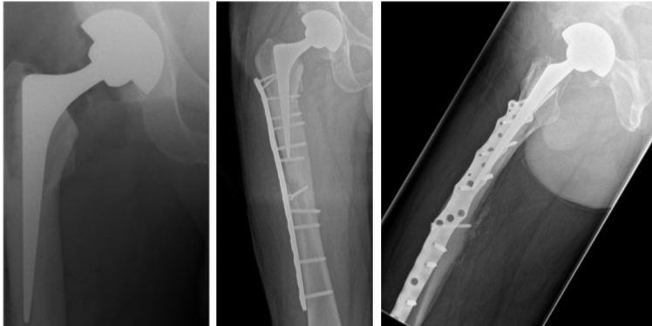
It was thought that the hip replacement was manufactured from cobalt chromium whilst the plate and screws were titanium.
The patient had a bowel MRI on a 1.5T Siemens system and reported no discomfort during or immediately after the scan. When the patient had left the department they began to experience a burning sensation in their right thigh with extreme pain. 21 sequences were run in total with a max SAR of 1.79W/kg. There was sequence of 9 breath-hold sequences run towards the middle of the exam where the SAR was always above 1 W/kg.
The conclusion from the report was that the extended and complex implant most likely suffered heating from the RF fields. It was highlighted that around 3% of patients have this combination of hip replacement with plate and these will have most likely been scanned without incident. They conclude that in this patient case a “unique combination of circumstances (e.g. implant configuration, position of patient in the scanner and types of sequences etc.) has contributed to the heating being excessive to the point where it caused the patient pain”

Anecdotal evidence (Date queried: 13/6/23)
A number of sites have confirmed through personal communication that they have written GISPs in place for orthopaedic implants. Details of these are below:
Guy’s and St Thomas’ NHS Foundation Trust: This policy is for fixed internal orthopaedic implants only and allows scanning immediately after implantation up to 3T with no SAR or spatial gradient restrictions. The patient should be warned to squeeze the alarm should they feel any unwanted sensations such as heating.
Great Glasgow and Clyde NHS: “All patients with fixed internal, passive orthopaedic implants who are conscious and have sensation can be scanned at 1.5T (and 3T) though they should be warned to hit the call button if they experience any heating or discomfort.”
“Patients with fixed internal, passive orthopaedic implants who are unconscious or lacking in sensation must have risks and benefits considered as a means of justifying their MRI scan”
Leeds Teaching Hospitals NHS Foundation Trust: Only fixed internal orthopaedic devices can be scanned which are securely fixed into bone. Scanning can be undertaken immediately after implantation at 1.5T and 3T in normal mode with no restriction on patient positioning. Seek advice for implants with loops/long rod (especially in LR/AP direction), external fixation devices, or adjustable systems (e.g Nuvasive Magec/Precece). ACL screws at 3T: introduce slowly to magnet, check for attraction discomfort.
InHealth mobile MRI supplier: “Patients with orthopaedic implants in situ, firmly secured to bone, are safe to scan immediately post insertion at both 1.5T and 3T, and on open scanner designs. Patients with large amounts of metallic implants in situ, such as hip replacements, should be monitored carefully due to the potential for heat generation and discomfort during the scan”. Scans be be undertaken at 1.5T and 3T with no SAR restrictions.
Great Ormond Street Hospital for Children NHS Foundation Trust: Policy includes passive metal implants fixed to bone which can be scanned at 1.5T and 3T with SAR limited to 2W/kg. No other conditions were applied except it was noted that there is increased importance to observe best practice when positioning the patient, in particular insulating pads to avoid skin to skin and bore to skin contact.
King’s College Hospital (sternal wires only): “Sternal wires and other sternal closure devices can be scanned immediately at 1.5T and 3T”.
On facebook Tobias Gilk recently undertook a survey asking how people approached orthopaedic implants. This highlighted that the majority of responders (85% of 396) do scan these generically

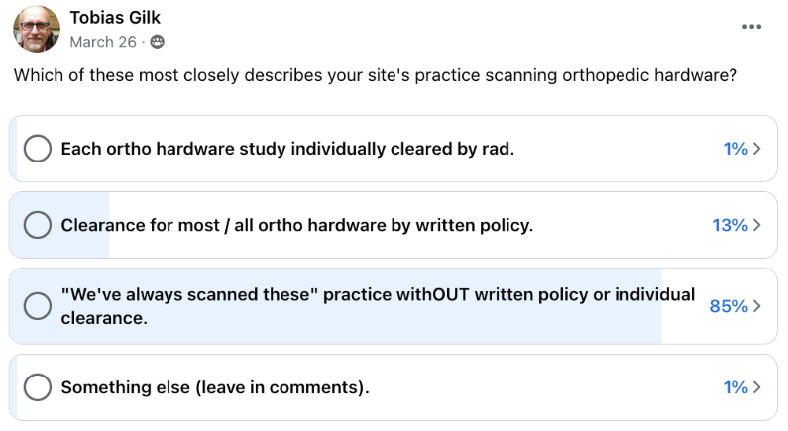
A similar survey was undertaken by the IPEM MR Generic implant safety procedures working party which found that 52% of 86 respondents across the UK (primarily MR superintendents) scanned orthopaedic implants generically.
These surveys potentially provide evidence that the scanning of orthopaedic implants is already common practice and given the sparsity of reported incidents is testament to them mostly being safe to scan.
Specific to sternal wires is the following:
Review of the SMRT MR Technologist mail base (performed 27/07/21)
There have been a few discussions of sternal wires and fixation devices on the SMRT mailbase, with Dr Kanal and Dr Shellock the most prominent contributors. In one thread relating to a sternal talon by KLS Martin (Figure 1), Dr Kanal expresses his concern for the potential for heating or dislodgment or arrhythmogenesis but Dr Shellock reported that they tested this as a single device in 2010, which resulted in MR Conditional labelling. However, the manufacturer’s documentation states that it has not been tested in the MR Environment and there remained concern about multiple sternal talons presenting an MR safety issue. Interestingly, mrisafety.com no longer hold information about the KLS Martin sternal talon.
In this discussion, it was suggested that the sternal talon is an example of a fixed, passive, internal orthopaedic implant and that these are generally not considered a contraindication for MRI. Dr Kanal was strongly opposed to this argument:
“I firmly disagree with any generalization that would suggest that any orthopedic hardware firmly attached bone would not present an MR safety issue. I also don’t believe that I ever heard anyone promulgate it, so this might actually be a bit of a misunderstanding. In any case, ferromagnetic large spine rods could experience extremely high rotational and/or translational forces in today’s 1.5T and 3T systems (let alone the recently FDA approved 7T systems). Further, I am personally aware of significant burns suffered at the tips of screws from bone-anchored orthopedic hardware. I would be exceedingly uncomfortable relying on such a generalization and of course would not accept nor permit my own institution to accept or follow such a “rule” for our patients.”
Later adding:
“I continue to repeat that the incessant drive we all seem to have to find and use absolute universal always applicable “rules” and “generalizations” is almost never in the best interest of safety but rather in the interest and pursuit of convenience. I continue to maintain that thoughtful prospective patient implant review is indicated for ALL implant patients.”
And:
“Generalizations do exist. Rarely. I personally tend to oppose the ones that are potentially dangerous, or unfounded, or unnecessary, and embrace the ones - the few - that work just about all the time.”
However, in a conversation earlier that same year about sternal ties, Dr Kanal appeared to suggest he does not check the approach used for sternal closure:
“I am not aware of any of them presenting MR-specific problems other than artifact potential. There is of course always a theoretical concern of possible heating, but I am not aware of confirmed reports of these having heated to a point of patient injury to date (even if they contain breaks in the ties, which as you are probably well aware is exceedingly common).”
Dr Shellock replied “I would not make general recommendations regarding the lack of MRI issues for those devices” and gave examples of single wire sternotomy designs that he thought had the potential to be an MRI safety concern.
Dr Kanal then made his approach to sternal wires clear in the following two statements:
“I personally do not hesitate to accept sternotomy sutures for MR scanning (even if they may have a break in them after several years of having been implanted in that patient, as it moderately common), and do not review what material was used or the type of closure utilized or the shape or "make or model” of the suture(s) closure(s) used. My rationale is as I have previously explained in this post-interchange - I am not personally aware of any type in use to this day that would present a significant MR risk.”
“TO reiterate, in my practice (and that of any and every MR site in the world of which I am aware) I do not review the type of sternotomy closure used in a given patient before permitting them access to an MR scanner to undergo a requested clinical MR examination. Maybe some could argue that we should! But this would certainly represent a massive shift in the standard of care being utilized to date. Should a given sternotomy closure system appear tin our collective futures that would make this a true clinical concern such as (I believe) Frank is suggesting from the “single wire” scenario posted below, this could of course be revisited in the future.”
This directly contradicts Dr Kanal’s later statements on generic policies and concerns around the sternal talon. He argues that a generic policy cannot encompass all situations and scenarios but that this is acceptable in the practice of medicine:
"if we ever get to the point where the widespread usage - or even initiation of usage - of closure devices that seem to present practical and real MR safety risks, we can start defining new screening practices if/as needed.
We so commonly hear people attempting to reduce a risk to zero. That is simply not always possible or practical. If you have ever taken a new medication, you should recognize that there is a small but finite risk that you could have died an anaphylactic death from so doing. Zero is not necessarily the only acceptable objective in the real world. Reasonable practices must be defined - by the industry and its experts - and by definition that might be sufficient for the vast majority of patients.
NOTHING in the above precludes ANY site from deciding to go far above and beyond any reasonable approach and exercising whatever additional steps they choose prior to accepting a patient into an MR study. Just recall that canceling a scan or significantly delaying it in urgent or emergent situations is also accompanied by its own risks - and liabilities.
This is the practice of medicine. We don’t attempt to issue guarantees, but rather excellent and reasonable practices to the best of our abilities in real world settings."
When reviewing the archived SMRT mailbase emails, one conversation reported a patient complaint of burning below the diaphragm while undergoing a T spine MRI. The patient had cardiac surgery 4 years before the MRI (which included sternal wires) and had some vascular clips visible on a chest x-ray. The patient had safely undergone previous MRIs without incident. The scan had a peak SAR above Normal Mode (2.9 W/kg in the sequence where the patient said it changed from a warming sensation to pain). Respondents questioned whether the MR coil was heating and recommended a field engineer tests the coil. It was also questioned why the patient wasn’t changed into a gown or scrubs but the original poster insisted the patient had no metal on their person. Dr Kanal concluded the conversation stating:
“To date I have not heard any confirmed reports of any patient injuries as a result of sternal wires. Recall that man of these are actually broken (i,.e., they split open over time), with small gaps between them. This would be a theoretical almost worst case scenario for RF-related thermal heating. Yet, for whatever reason, I am not aware of any alleged injuries related to sternal wires. Presumably the cross sectional area of these loops is quite small and (relative to the power being transmitted) insufficient to generate enough heat per time for tissue injury to occur. However, this is purely conjecture, and I must admit that frankly I am mildly surprised that no injuries have been reported/confirmed related to sternal wires to date.”
Another conversation from the SMRT archive highlighted than neither Dr Kanal nor Dr Shellock had concerns about scanning a research patient with sternal wires at 3T, despite the lack of clinical benefit to the patient. Dr Shellock highlighted that, at the time of writing in 2014, less was known at 7T.
One post raised the issue that active implants often state they have not been tested with other implanted devices. The specific example was sternal wires alongside a Medtronic REVEAL device. Tobias Gilk suggested the use of a T/R head coil to eliminate the risk from RF but acknowledged he would not have a concern about the combination of these implants provided they cleared individual MR safety checks.
Search terms included “sternal” and “talon” and identified 73 posts. It is worth noting that some of the older comments have been deleted (including some from Dr Shellock), which hinders interpretation.
Generally, posters had little concern around the safety of sternal wires, including immediately post-implantation. Dr Shellock suggests that these should be treated like any other metallic implant, e.g. check make and model, orientation of wires, MR safety labelling etc., but others suggest it is impractical and unnecessary to do this given the low risk of heating. There was more concern around other sternal fixation devices but this is primarily around the lack of formal MR safety testing/labelling rather than anything known to be inherently unsafe.
The RTI surgical sternal cable (figure of 8 system) was mentioned in 2016. Dr Shellock said he was in the process of testing it but there doesn’t appear to be anything on the manufacturer or Dr Shellock’s website. He mentioned the multiple configurations the implant could be implanted with so perhaps that caused an issue with the MR safety labelling. In any case, Dr Shellock seemed sufficiently concerned with heating to indicate a T/R head coil may be advisable for the specific research participant.
Broken sternal wires are discussed a few times. Often, the use of a T/R coil is suggested to minimise the risk. However, many posters reported previous MRI scans of patients with broken sternal wires and others questioned how often these would have been scanned without knowing they are broken given they are often scanned without checking a chest x-ray. One poster said one patient’s wires had “exploded” but that they were all retained in the chest wall (not in the heart or lungs) and the patient was able to be scanned safely after Radiologist sign off.
A poster asked if there were any concerns scanning sedated patients with sternal wires at 3T. The general consensus seemed to be that this is safe but Dr Shellock was keen to know the type and configuration of the wires first.
In 2017, a contributor reported that a patient with sternal wires reported burning in their chest and had to stop the MRI scan but the patient’s chest did not feel warm to the radiographer. Dr Shellock suggested this is likely to be rapid vibration from the metallic implants. Another poster suggested it might have been a claustrophobic patient. A further responder said that they had been scanning sternal wires since 1988 and only ever had two patients report “stinging and burning along the skin over their sternum”, and only these two patients no longer get MRI. In other posts, two more contributors reported that a patient of theirs with sternal wires reported pain during their MRI scan.
Mr Gilk has said on a few occasions that sternal wires represent low risk of potential harm and that there should not be any wait post-implantation of sternal wires.
There were a few posts discussing the KLS Martin Sternal Talon (Figure 1). Dr Shellock suggests that they should be treated as MR Unlabelled and therefore a Radiologist should perform a risk vs. benefit decision whether to scan. He points out that whilst the article by Levin and colleagues (2010) states it is “MRI compatible”, the article does not provide proper MRI testing information to support this statement. It was reported in 2016 that Dr Shellock had tested them previously and listed them as MR Conditional 6 on his mrisafety.com website but this has since been removed. All links to the KLS Martin website do not work any longer but a screenshot of part of the guidance has been copied below which mentions “irritating artifacts” and “MRIs are not permitted unless potential patient injury can definitely be ruled out” (Figure 2). Furthermore, one contributor mentioned that their department received a memo from KLS Martin that their “FDA testing was obsolete due to revised FDA guidelines”.
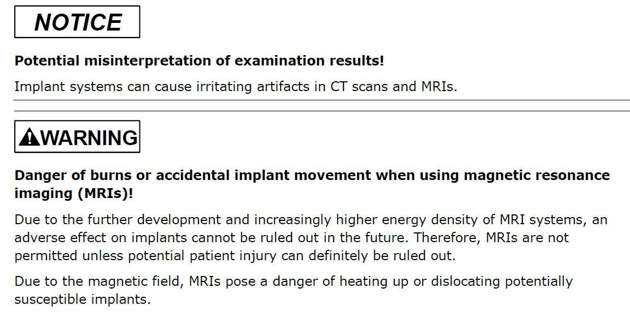
Figure 2: Extract from KLS Martin’s Sternal Talon MRI guidance document
Dr Shellock states that the main concern for the KLS Martin Sternal Talon is MRI related heating and that the “magnetic field interactions (force and torque) are non-issues”. A few contributors reported that they have scanned this device on a 1.5T system, totalling four patients, following Radiologist approval, and no adverse effects were noted during or post-scan. Another few contributors had known of a patient scanned with this device but provided no further details. A T/R coil was suggested to reduce the risk.
A patient with sternal talons reported heating when undergoing an MR knee scan. Dr Shellock said that this was impossible if a T/R knee coil was used but suggested gradient induced vibration could have been perceived as heating.
The Waston Medical sternal fixation system was identified through this search. It appears to be MR Unlabelled but I sent an enquiry to the company for an update. The response from Waston Medical confirmed that it is MR Unlabelled but that they are currently performing the MRI tests and expect it to be “safe in MRI” as it is pure titanium. I highlighted the risk from RF heating in my response and asked to be updated once the MRI safety testing was complete. Until this time, it must be considered MR Unlabelled.

Local MR safety databases and empirical evidence (Date queried: 11/07/23)
Locally orthopaedic implants have been scanned generically (albeit without a specific policy in place). There has been reported incidents from this practice.
A search of the implant safety queries received by the NHS Greater Glasgow and Clyde MRI Physics group since the introduction of a generic shared email (~November 2017-July 2021) highlighted 4 cases specifically involving sternal wires. All 4 of these cases were recommended to scan without knowing the make or model of the sternal wire. In one case the sternal wire was known to be made from stainless steel and in another case the patient also had a pacemaker implanted. We are not aware of any issues arising from these scans.

Discussion (optional)

See Risk Assessment

References
Baikoussis, Nikolaos G., et al. "Safety of magnetic resonance imaging in patients with implanted cardiac prostheses and metallic cardiovascular electronic devices." The Annals of thoracic surgery 91.6 (2011): 2006-2011.
Diken, Adem İlkay, et al. "The reliability of magnetic resonance imaging in patients undergoing cardiologic and cardiovascular surgical interventions." (2016).
Leitgeb, Norbert, Gerhard Loos, and Franz Ebner. "MRI-induced tissue heating at metallic sutures (cerclages)." (2013).
Levin, Lawrence Scott, et al. "An innovative approach for sternal closure." The Annals of thoracic surgery 89.6 (2010): 1995-1999.
Levine, Glenn N., et al. "Safety of magnetic resonance imaging in patients with cardiovascular devices: an American Heart Association scientific statement from the Committee on Diagnostic and Interventional Cardiac Catheterization, Council on Clinical Cardiology, and the Council on Cardiovascular Radiology and Intervention: endorsed by the American College of Cardiology Foundation, the North American Society for Cardiac Imaging, and the Society for Cardiovascular Magnetic Resonance." Circulation 116.24 (2007): 2878-2891.
Nazarian, Saman, Henry R. Halperin, and David A. Bluemke. "Safety Considerations of Current and Evolving CMR Techniques and Hardware." Novel Techniques for Imaging the Heart: Cardiac MR and CT. Wiley-Blackwell, Ltd, 2009. 43-54.
Shellock, Frank G. "Biomedical implants and devices: assessment of magnetic field interactions with a 3.0‐Tesla MR system." Journal of Magnetic Resonance Imaging: An Official Journal of the International Society for Magnetic Resonance in Medicine 16.6 (2002): 721-732.
Symons, Rolf, Stefan L. Zimmerman, and David A. Bluemke. "CMR and CT of the patient with cardiac devices: safety, efficacy, and optimization strategies." JACC: Cardiovascular Imaging 12.5 (2019): 890-903.
Zheng, Jianfeng, et al. "Wire‐based sternal closure: MRI‐related heating at 1.5 T/64 MHz and 3 T/128 MHz based on simulation and experimental phantom study." Magnetic resonance in medicine 83.3 (2020): 1055-1065.

Risk Assessment

Hazards

- Displacement due to ferromagnetic implant
- Vibration of implant leading to unwanted sensation
- Heating of implant
- Patient scanned with active implant due to confusion with passive implant at screening

Description of Risk

- Displacement due to ferromagnetic implant

Historically there are ferromagnetic implants and some examples of these have been tested in MRI and showed to demonstrate significant deflection. However, there have been no known reported incidents from these implants, and it is accepted that the anchoring of the orthopaedic implant into bone provides a secure fixation removing the risk of implant movement.
The most restrictive spatial gradient limit identified from the evidence review was 7.2T/m. Modern day wide bore scanners typically have spatial gradients greater than this value which are accessible by the patient. It is possible that these restrictive spatial gradient limits set by the manufacturers are the limits in testing rather than a limit at which injury may occur. Therefore, the risk of injury from any modern 1.5T or 3T scanner can considered to be extremely low. To minimise the risk however, it is recommended that patient should avoid regions of high spatial gradient local close to the edge of the bore. The patient should be positioned on the scanner couch as far away from the bore as possible and should be asked to maintain their position laying on the couch until the study has finished.
- Vibration of implant leading to unwanted sensation

There have been anecdotal reports of patients experiencing unwanted (tingling) sensation from implants which was potentially attributed to torque from eddy currents generated from the gradient fields. Scientific publications have verified there is potential for eddy current induced torque effects for larger implants although given the sparsity of genuine incidents it would seem this effect is minor and does not pose a significant risk.

- Heating of implant

The greatest risk when MRI scanning orthopedic implants is heating of the implant due to the RF field. There have been a number of reported incidents via the regulatory reporting bodies which suggest heating may have occurred in some patients. In particular it has been reported in patients with Nuss bars and hip replacements. It is difficult to substantiate the real cause of these incidents and if MRI is truly the origin. For example for the bilateral hip replacement incident discomfort and pain was felt during and immediately after a high SAR sequence. For the incident involving a hip replacement in combination with a femoral plate the pain was experienced after the patient had left the department. Nonetheless, scientific studies do report temperature rises from numerical simulations and phantom measurements of up to 6.4ºC at a WB SAR of 2W/kg and one manufacturer reports a temperature rise of up to 14.7 ºC for a WB SAR of 2.12W/kg within their IFU’s (with WB SAR conditions for scanning of 2W/kg). Many of these studies however, highlight that the cooling effects of perfusion are not included in their experiments. The worst case theoretical heating occurred for studies involving a humeral nail aligned with the coil (and scanner) axis and positioned off axis at the edge close to the bore. Other studies considered complex implants with multiple elements and they highlighted that the temperature increase in such a scenario was 2.7x greater than for sole implants. Finally, it was commented that there was a greater theoretical concern for heating in implant that had “pointy”, “sharp” components or wires. Hence a worst-case scenario for potential heating would have the following characteristics:
- Long implants
- Off-axis from the centre of the scanner (close to the bore wall)
- Multiple components in close proximity
- Contains sharp components or wires.
The risk of heating has led some manufacturers to release implants with low SAR limits in their labelling or to have restrictions on scan times and rest periods between scanning. These limits appear to be based on the measurement of temperature increase during testing of their device following the appropriate ASTM standard. Given the prevalence of scanning of orthopaedic implants without identifying make and model in the MRI community and given the limited number of incidents it potentially suggests that these conditions are overly conservative.
Nonetheless, given the evidence, i.e the manufacturers restrictions to limit heating, the results from simulation and phantom studies and the reported incidents suggesting pain and discomfort in patients with orthopaedic implants. It would suggest there is a genuine risk of heating resulting in discomfort and pain and there is potential of under-reporting of heating-related events. This may be because heating experienced by patients with such implants has not been thought to warrant reporting as it did not result in a visible external burn. Or perhaps patients were not aware of heating at the time of the MRI scan and have subsequently developed reddening of their skin and have either not associated this with the MRI scan or have simply not informed the relevant MRI department of this thermal injury. The case report from the IPEM safety meeting (2023) attests to this delayed effect
- Patient scanned with active implant due confusion passive implant at screening

In recent years a variety of active orthopaedic implants have been available on the market (e.g magnetically activated growth rods such as the MAGEC and PRECICE devices and bone fusion stimulation devices). Some of these are labelled as MR Conditional whilst others are labelled as MR Unsafe. There is a risk that these could be mistaken for a passive device (e.g the MAGEC device being thought of as a standard Harrington rod) in which case the patient would be put at risk. Some studies that have investigated the risk to these devices specifically the PRECICE magnetic lengthening femoral and tibial nails. They found the only negative impact of the MRI scan was to reduce the magnitude of the force to lengthen and contract the device.

Existing precautions

- Patients are given the squeeze alarm such that they could inform the radiographer should they feel discomfort.
- Patient must be scanned in normal mode.
- Patients are screened to ensure to accurate information regarding the nature of the device avoiding the confusion between passive and active devices. If there is any uncertainty the device should be further investigated.
- Prevention of contact with scanner bore by the use of non-conducting foam pads of 2cm thickness.
- Prevention of induction loops by careful positioning of the patient and use of non-conducting foam pads at potential contact points between tissue e.g. thigh-thigh or between tissue and equipment cables.
- Restricting the scan duration to the minimum required for diagnosis.
- Interleaving high SAR scans with low SAR scans or generally leaving a time gap between applied sequences.
- Where possible and for higher risk cases use of a Transmit receive coil to image an area away from the implant site.

Additional focus on reducing SAR to mitigate heating should be considered in the following higher risk cases:
- Individuals with a compromised thermoregulatory response
- Individuals who are unable to provide immediate feedback on heating sensation such as patients under general anaesthetic or sedation or with disabled or partially dysfunctional perfusion abilities or dysfunctional heat sensation.
- Individuals who are anatomically large, broad, or obese They will likely be closer to the scanner bore (and hence to the body RF transmit coil) and may also provide a larger induced current path.
- MR imaging when the landmark position is over the implant.
- Devices which seem abnormally large or have multiple complex components particularly when these components have short gaps between them.
- When an elongated implant is positioned parallel to the distribution of the induced electric field in the body and in regions of high electric field (Ref 3). Electric field distribution will vary with body tissue distribution. Generally, for a landmark position at lower thorax/upper abdomen, an elongated implant at the periphery of the body or across shoulders or pelvis may meet this condition.

Level of Risk

The risk level is highlighted in bold on the risk matrix below

Risk Matrix
Likelihood |  | Impact/Consequences
 | Negligible | Minor | Moderate | Major | Extreme
Almost Certain | Medium | High | High | V High | V High
Likely | Medium | Medium | High | High | V High
Possible | Low | Medium | Medium | High | High
Unlikely | Low | Medium | Medium | Medium | High
Rare | Low | Low | Low | Medium | Medium

Medium (Yellow) High (Orange) or Very High (Red) risks are unacceptable. A GISP should only be created where the risk is low

